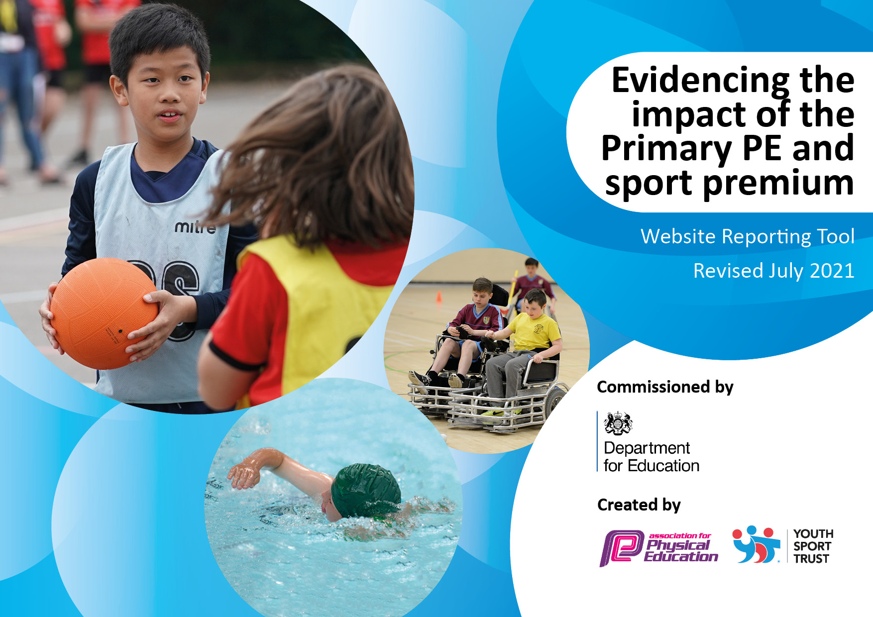
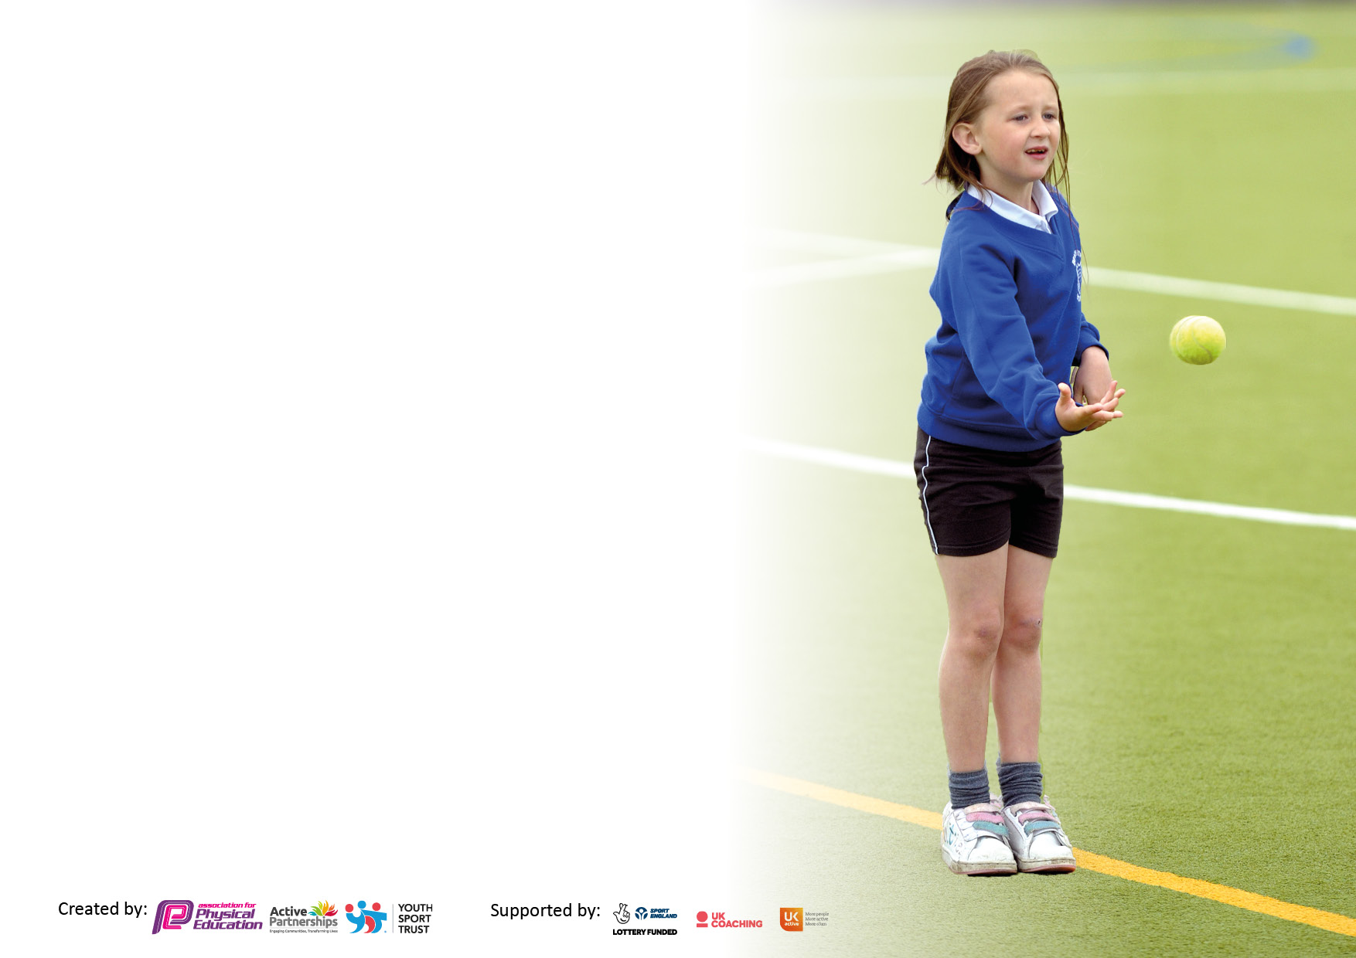

It is important that your grant is used effectively and based on school need. The Education Inspection Framework makes clear there will be a focus on ‘whether leaders and those responsible for governors all understand their respective roles and perform these in a way that enhances the effectiveness of the school’.

Under the Quality of Education Ofsted inspectors consider:
Intent - Curriculum design, coverage and appropriateness
Implementation - Curriculum delivery, Teaching (pedagogy) and Assessment
Impact - Attainment and progress

To assist schools with common transferable language this template has been developed to utilise the same three headings which should make your plans easily transferable between working documents.

Schools must use the funding to make additional and sustainable improvements to the quality of Physical Education, School Sport and Physical Activity (PESSPA) they offer. This means that you should use the Primary PE and sport premium to:

- Develop or add to the PESSPA activities that your school already offer
- Build capacity and capability within the school to ensure that improvements made now will benefit pupils joining the school in future years
- The Primary PE and sport premium should not be used to fund capital spend projects; the school’s budget should fund these.

Pleasevisitgov.ukfortherevisedDfEguidanceincludingthe5keyindicatorsacrosswhichschoolsshoulddemonstrate animprovement.Thisdocumentwillhelpyoutoreviewyourprovisionandtoreportyourspend.DfEencouragesschools to use this template as an effective way of meeting the reporting requirements of the Primary PE and sport premium.

We recommend you start by reflecting on the impact of current provision and reviewing the previous spend.

Schools are required to publish details of how they spend this funding, including any under-spend from 2019/2020, as well as on the impact it has on pupils’ PE and sport participation and attainment. All funding must be spent by 31st July 2022.

We recommend regularly updating the table and publishing it on your website throughout the year. This evidences your ongoing self-evaluation of how you are using the funding to secure maximum, sustainable impact. Final copy must be posted on your website by the end of the academic year and no later than the 31st July 2021. To see an example of how to complete the table please click HERE.
Created by: Supported by:

Details with regard to funding
Please complete the table below.

Total amount carried over from 2020/21 | £7329
Total amount allocated for 2021/22 | £17,261
How much (if any) do you intend to carry over from this total fund into 2022/23 | 0
Total amount allocated for 2022/23 | £17,620
Total amount of funding for 2022/23. To be spent and reported on by 31st July 2023. | £17,620
Swimming Data
Please report on your Swimming Data below.

Meeting national curriculum requirements for swimming and water safety.

N.B. Complete this section to your best ability. For example you might have practised safe self-rescue techniques on dry land which you can then transfer to the pool when school swimming restarts.
Due to exceptional circumstances priority should be given to ensuring that pupils can perform safe self rescue even if they do not fully meet the first two requirements of the NC programme of study
What percentage of your current Year 6 cohort swim competently, confidently and proficiently over a distance of at least 25 metres?  N.B. Even though your pupils may swim in another year please report on their attainment on leaving primary school at the end of the summer term 2021.  Please see note above | 72%
What percentage of your current Year 6 cohort use a range of strokes effectively [for example, front crawl, backstroke and breaststroke]?  Please see note above | 72%
What percentage of your current Year 6 cohort perform safe self-rescue in different water-based situations? | 50%
Schools can choose to use the Primary PE and sport premium to provide additional provision for swimming but this must be for activity over and above the national curriculum requirements. Have you used it in this way? | Yes/No Additional allocation of £1200

Action Plan and Budget Tracking
Capture your intended annual spend against the 5 key indicators. Clarify the success criteria and evidence of impact that you intend to measure to evaluate for pupils today and for the future.

Academic Year: 2022/23 | Total fund allocated: 17,620 | Date Updated: July 2023
Key indicator 1: The engagement of all pupils in regular physical activity – Chief Medical Officers guidelines recommend that primary school pupils undertake at least 30 minutes of physical activity a day in school |  |  |  | Percentage of total allocation:
 |  |  |  | 60%
Intent | Implementation |  | Impact
Your school focus should be clear what you want the pupils to know and be able to do and about  what they need to learn and to  consolidate through practice: | Make sure your actions to achieve are linked to your intentions: | Funding allocated: | Evidence of impact: what do pupils now know and what can they now do? What has changed? | Sustainability and suggested next steps:
- To further develop the outdoor environment and resourcing to promote positive physical play at break and lunchtimes  - To further develop the learning environment and resources to develop gross motor skills which will impact on progress and achievement across the curriculum  - To further develop the learning environment and resources to promote healthy lifestyles and positive mental health, self-confidence and well-being, which will impact on progress and achievement across the curriculum  - Develop use of Real PE which as a tool which can be used to engage all pupils by setting appropriate levels of challenge and feedback on how to improve and develop | - Audit current provision and environment seeking children’s views and evaluating levels of engagement  - Identify and purchase resources to engage pupils of each stage and age  - Continue to resource play leaders to support across school  - Understand developmentally what children at each age and stage should be expected to achieve and ensure that appropriate provision and resource is in place to support this  - Continue to resource forest school provision across the school and the wider outdoor learning environment  - Identify other agencies who could promote healthy lifestyles with groups of children – buy in resource to support school curriculum  - Use CPD from Real PE to support staff to deliver units of work across the year  - Evaluate impact on children in terms of confidence, skill development and levels of engagement | £2907  £100  £6552  £400  £200  Included in cost of NFSSP | At playtimes/lunchtimes, pupils are visibly engaged in physical activity.  They can independently and safely access a range of resources and equipment.  As a result of actions taken, behaviour in the main is positive with pupils engaged in activity.  In EYFS, the environment supports safe development of gross motor skills through engagement in outdoor play.  In EYFS and KS1 , children can demonstrate that they have met the expected level of development for gross motor skills and this will be impacting positively on their engagement across the curriculum  There will be evidence that children understand what we mean by a healthy lifestyle.  They will be able to make healthy life choices and this will include seeking support when they are worried or anxious.  Children will be able to identify ways which they can use to help themselves regulate their emotions or negative feelings.  During lessons, pupils will be seen to be engaged in all aspects of the lesson.  Children will demonstrate that they are learning new skills and developing existing skills. They will be able to talk about what they have learnt and demonstrate that they have listened and responded to feedback. | Equipment will need continuous replenishment  Updated training for lunchtime staff required  We will be evaluating and looking at other adventurous play options around the school to develop physical play during break times  Continued work with Countryside trust on gardening and cooking healthy meals – continued budget spend
Key indicator 2: The profile of PESSPA being raised across the school as a tool for whole school improvement |  |  |  | Percentage of total allocation:
 |  |  |  | 10%
Intent | Implementation |  | Impact
Your school focus should be clear what you want the pupils to know and be able to do and about  what they need to learn and to  consolidate through practice: | Make sure your actions to achieve are linked to your intentions: | Funding allocated: | Evidence of impact: what do pupils now know and what can they now do? What has changed? | Sustainability and suggested next steps:
- Development of PE lead and in turn wider understanding of how PE, school sports and physical activity look across the school and inter-link  - Develop links with other providers to improve offer and engage pupils with a range of levels of skill and interests  - Continue to develop awards and opportunities to celebrate successes across the year, including the development of our ‘Sports Awards’ evening which recognises achievements in a wide range of areas | - PE lead to be released to evaluate curriculum to date. What is our intent? Implementation and desired impact?  - Conduct pupil surveys to ascertain impact of curriculum to date  - Creation of action plan to drive improvement  - Time to collaborate with sports coach and evaluate school offer  - Identify external providers to offer workshops and enrichment sessions for pupils Eg: Shine Cricket, Dance  - Year overview identifying opportunities to celebrate and award achievements in sport and PE  - Annual awards evening to be held with parental audience | £600  £1500  £300 | - There is a clear vision for PESSPA at Waterside  - Curriculum planning in place to support all staff to teach a stage appropriate curriculum which offers appropriate levels of support and challenge  - When observed, pupils are engaged with lessons and make progress, responding to feedback and formative assessments  - Teacher or coach led sessions are supported and enriched with visits from experts and ambassadors of sport  - Children are able to talk about awards for sport and PE and value is shown to these awards and events by children and parents | Further time will be required next year to engage in CPD and feedback to other staff

Key indicator 3: Increased confidence, knowledge and skills of all staff in teaching PE and sport |  |  |  | Percentage of total allocation:
 |  |  |  | 11%
Intent | Implementation |  | Impact
Your school focus should be clear | Make sure your actions to | Funding | Evidence of impact: what do | Sustainability and suggested
what you want the pupils to know | achieve are linked to your | allocated: | pupils now know and what | next steps:
and be able to do and about | intentions: |  | can they now do? What has
what they need to learn and to |  |  | changed?
consolidate through practice:
- Development of PE lead and in turn wider understanding of how PE, school sports and physical activity look across the school and inter-link  - Real PE training for all staff to ensure that they can confidently teach pupils at all levels of skill providing support and challenge through accessing resources | - PE lead to be released to evaluate curriculum to date. What is our intent? Implementation and desired impact?  - Conduct pupil surveys to ascertain impact of curriculum to date  - Creation of action plan to drive improvement  - Time to collaborate with sports coach and evaluate school offer  - Facilitate Real PE training for all staff  - Share resources  - Monitor lessons and feedback – coaching as required | See above  See above | - There is a clear vision for PESSPA at Waterside  - Curriculum planning in place to support all staff to teach a stage appropriate curriculum which offers appropriate levels of support and challenge  - When observed, pupils are engaged with lessons and make progress, responding to feedback and formative assessments  - PE taught by teachers will demonstrate an understanding of the Real PE scheme – teachers will be effectively using resources and children will be making visible progress across the course of a series of lessons
Key indicator 4: Broader experience of a range of sports and activities offered to all pupils |  |  |  | Percentage of total allocation:
 |  |  |  | 9% (but see also above)
Intent | Implementation |  | Impact
Your school focus should be clear | Make sure your actions to | Funding | Evidence of impact: what do | Sustainability and suggested
what you want the pupils to know | achieve are linked to your | allocated: | pupils now know and what | next steps:
and be able to do and about | intentions: |  | can they now do? What has
what they need to learn and to |  |  | changed?
consolidate through practice:
- Ensure all pupils have access to extra-curricular PE and sports opportunities regardless of parental income – increase range and choice  - Ensure all pupils have residential opportunities in Years 4 and 6 regardless of parental income as here they will experience a range of adventurous activities | - Evaluate sporting opportunities on offer  - Identify other groups to provide extra-curricular sessions  - Identify target pupils and engage in enrichment opportunities  - Additional forest school sessions for vulnerable pupils  - When planning residential activities or activity week, ensure that activities on offer provide a range of new and challenging activities  - Offer part funding to vulnerable families, those in receipt of PP and other families who are unable to afford the total fee | See above  (Dance etc..)  £700  £1200 | - Wide range of activities on offer across the year  - An increased percentage of children accessing activities  - Target pupils supported to attend and further opportunities identified for individuals or groups as appropriate  - All Year 4 and Year 6 pupils will engage with residential and activity trips, fully emerging themselves in the activities including: climbing, skiing, kayaking, archery etc…. | Investigate other groups and areas of interest from local area Eg: Archery

Key indicator 5: Increased participation in competitive sport |  |  |  | Percentage of total allocation:
 |  |  |  | 10%
Intent | Implementation |  | Impact
Your school focus should be clear | Make sure your actions to | Funding | Evidence of impact: what do | Sustainability and suggested
what you want the pupils to know | achieve are linked to your | allocated: | pupils now know and what | next steps:
and be able to do and about | intentions: |  | can they now do? What has
what they need to learn and to |  |  | changed?
consolidate through practice:
- Seek opportunities for involvement in a wider range of sports and activities through association with NFSSP and local secondary schools, but also provide opportunities for competition within class PE lessons  - Provide opportunities for pupils to meet with sports men and women to share careers, aspirations and journey’s | - Continue to sign up to NFSSP  - Attend as many events as possible across the course of the year  - Plan regular opportunities for competition in school – athletic awards, ticket run etc…..  - Identify other opportunities for those children who demonstrate talent to compete both in and out of school  - Identify visiting athletes and sportsmen from a range of backgrounds to share stories with children | £1800  £400 | All children will have regular opportunities to compete against their peers  A good proportion of children across the year groups will have had an opportunity to compete against pupils from another school | Look to secure parental support for transport and utilise HTLA cover for competitions

Signed off by
Head Teacher: | E.Moakes
Date: | 20.7.23
Subject Leader: | Mrs J Marsh
Date: | 20.7.23
Governor: | Ms H Gilmore
Date: | 20.7.23

