 |  | AUTUMN TERM |  | SPRING TERM |  | SUMMER TERM
 |  | Aut 1- Stone Age, Bronze Age and Iron Age  Aut 2 – Local area study of Hythe - Historical |  | River Deep, Mountain High |  | Ancient Egyptians
Hook into topic |  | Hillier Gardens |  | Testwood Lakes
Home learning project |  | Interview somebody that has lived in Hythe for a ‘long time’ to bring in to school – ask about how it has changed. |  | Create a 3D model of the three courses of a river. |  | Create an Egyptian Death Mask
Class trip or visitor |  | Hillier Gardens |  |  |  | Hindu temple and St Johns (RE places of worship)
English | English  Key Texts for Writing | Stone Age Boy – Satoshi Kitamura  How to Wash a Woolly Mammoth | The Present – Literacy Shed  Emperor of Absurdia– Chris Riddell | Flood – Villa F Alvaro  Windmill Farmer – Literacy Shed Plus | An Alien in the Jam Factory – Chrissie Sains  Information texts – Mountains | Mole’s Sunrise – Jeanne Willis  Calligrams / Shape poetry | Wisp – Zana Fraillon and Grahame Baker-Smith  Cinderella – Shirley Climo
English | Writing Outcomes | Narrative Adventure story – Stone age boy –  Write an adventure story from the point of view of a stone age character.  Instructions – How to wash a woolly mammoth | Narrative – The Present, write the story for the video  Narrative Circular Stories – Emperor of Absurdia | Recount Recorded New Reports – Flood  Being in a situation with a flood  Letter/Newspaper Report  Windmill Farmer | Persuasive writing – Letter to Scooters parents to keep Fizzbee  Non-Chronological report - mountains | Narrative – Re-write Mole’s Sunrise (Mole’s Walk)  Alternative fairy-tales – The True Story of the 3 little pigs – Jon Scieszka | Narrative – Familiar stories – The Egyptian Cinderella  Poetry – Calligrams/Shape Poetry
English | Shared Reading Texts  (NF)  (F)  (P) | Once upon an Ordinary Boy – Satoshi Kitamura – Colin McNaughton  Two Frogs – Chris Wormell | Lob – Linda Newbery (F) | River Story – Meredith Hooper | Stone Girl, Bone Girl – Laurence Anholt | Butterfly Lion - Michael Morpurgo | The Bolds – Julian Clary
English | Read Aloud | The Abominables – Eva Ibbotson | Lob – Linda Newbery | Fortunately the Milk – Neil Gaiman | An Alien in the Jam Factory | Butterfly Lion - Michael Morpurgo | The Bolds – Julian Clary
Maths |  | 3.1-3.3  Place Value, Addition and Subtraction with measures, Multiplication and division | 3.4-3.5  Fractions and Geometry, Place value with measurement | 3.6-3.7  Fractions and Geometry, subtraction and addition | 3.8-3.10  Time, multiplication and division with fractions, subtraction and addition with statistics | 3.11 – 3.13  Multiplication and division, Geometry, Addition and Subtraction | 3.14-3.16  Multiplication and division with fractions, Measurement with money and time, measurement with length
Computing |  | Connecting computers  Animation |  | Sequence in music  Desktop publishing  CANVA & Pixabay.com |  | Events and actions  Branching databases  Airtable/PM
Humanities | History | The Stone Age, Bronze Age and Iron Age – Autumn 1  The Stone Age began 4 million years ago when the first humans lived in Africa.  The first people arrived in Britain over 700 000 years ago – modern humans (Homo sapiens) first appeared around 20 000 years ago.  The Stone Age can be broken down further into Palaeolithic, Mesolithic and Neolithic periods.  During the Stone Age, people used predominantly stone tools to kill and collect food (hunter-gatherers).  Stone Age people may have used art (cave paintings) as a way to help themselves survive.  Stonehenge was built around 3000 BC to 2000 BC.  The Stone Age ended around 4000 BC when people mined copper and discovered how to make bronze. (the bronze age)  Know that life was different in Skara Brae compared with other Stone Age settlements.  Stone Age people changed from hunter gathers to farmers during the Neolithic period.  In the Bronze Age (2500 BC to 800 BC) ancient Britons learned to work with copper, tin, gold and bronze.  People in Britain learned to make iron around 800 BC (Iron Age 800 BC to AD43). They used iron to make tools and weapons.  During the Iron Age, farming flourished and the British population grew very fast.  The Iron Age was a very violent time and many people live in hill forts to protect themselves. (Old Sarum)  Know that AD 43 is when Romans invaded Britain and began written historical records and this is around the time the Iron Age ended.  Local History Hythe then and Now – Autumn 2  The name Hythe means landing-place or haven.  Hythe is recorded in a Parliamentary roll from 1293.  The Hythe ferry ("Hitheferye") to Southampton is marked on a map by Christopher Saxton of 1575, and on a map by John Harrison in 1788.  Hythe was part of the parish of Fawley, although it became a separate ecclesiastical parish in 1841.  The current church, of Saint John the Baptist, was erected in 1874. It is of red brick with Bath Stone dressings.  There were at one time stocks in the village.  Thanks in part to the British Power Boat Company and its excellent access to the English Channel, during World War II Hythe was used as a port for the "little ships" of the Royal Navy, the Motor Torpedo Boats and the RAF Air/Sea Rescue Boats.  In 1960, The Hovercraft Development Company and Sir Christopher Cockerell, its founder, moved to Hythe.  There was a small Royal Air Force base in Hythe known as RAF Hythe. Until its closure in September 2006 it was used by the United States Army to service and maintain watercraft.  Langdown House was built for George Tate in 1797. It was bought by the Hobart family in 1849.  In the 1920’s the Hobart family opposed the building of the new Totton to Fawley railway.  1925 Totton to Fawley train line built (year 1 prior knowledge)  Sir Robert Hobart died in Langdown House –August 4th 1928 (aged 91)  In the 1930’s the house was owned by BOAC.  1940-45 the house was the Ward room for HMS Dilligence – a naval base on the Shore Rd. at Hythe.  Hythe was a village up to the 1950s, but the expansion of Fawley Refinery led to a demand for more houses for workers, and Hythe and Dibden Purlieu were allowed to expand into a small town.  Langdown House was demolished in 1961. |  |  |  | Ancient Civilisations with a focus on the Ancient Egyptians  (All forms part of the same unit)  Four ancient civilisations were - Shang Dynasty, Ancient Egyptians, Ancient Sumer and Indus Valley.  The Shang Dynasty was ruled under the Shang family in China from around 1600 BCE to 1046 BCE. Their empire reached far into the East China Sea, beyond the Yellow River. The Shang way of living and its traditions reached very far throughout China.  Ancient Sumer - People began living in the area we call Sumer from around 5000 BC. Sumer no longer exists: the land is part of Iraq. The Sumerians built large cities and invented a written script. They had a significant effect on the world as it is today.  Indus Valley – civilisation covered an area four times the size of the UK. It centred in the Indus River, in modern day northeast Afghanistan, Pakistan and northwest India.  The Ancient Egyptians (All forms part of the same unit)  Cairo is the capital of Egypt  The River Nile is the longest river in the world.  People settled near the Nile as it was a useful source of water (used for drinking, washing, watering crops)  Egyptians relied on the Nile’s flood to grow crops and farm.  Area near the River Nile that flooded was known as the Black Land. Areas further away were known as the Red Land.  3100BC - 30BC Ancient Egyptian era  2,640 BC First pyramid is believed to be built - ‘Step Pyramid’. It was built in sandstone and encased in limestone, standing 70 metres tall. (2950-2975 BC) This pyramid still stands today.  2,520 BC The Great Sphinx (body of a lion and head of a human) is believed to be built.  1,332 BC Tutankhamun begins 10-year rule.  51 BC Queen Cleopatra’s reign begins. She is the last Pharaoh of the ancient Egypt period  332 BC – Alexander the Great conquers Egypt.  The Pharoah and those that were linked to religion were the most powerful in society.  Pharaohs were usually buried under the pyramid structure although some had burial chambers built inside the pyramid.  Mummification was an embalming process used to preserve the body ready for the afterlife.  Ancient Egyptians worshipped a great number of Gods and Goddesses.  Ancient Egyptians used Hieroglyphs as a form of writing. Ancient Egyptians wrote on scrolls made from of papyrus plant.  The pharaoh got the rich peasants to do the farm work on the rich lands. Most villagers were farmers. Farmers lived in towns too, along with craft workers, traders and other workers and their families.  Rosetta Stone - discovered in 1799 at the port of Rosetta in Egypt.  Nov 1922 Howard Carter discovers the tomb of Tutankhamun in the Valley of the Kings  Early in Egyptian history, the people made huts for their houses out of mud and papyrus reeds (a local plant). Egyptians made mud bricks to build stronger houses.
Humanities | Geography |  |  | River Deep…  England, Ireland, Scotland, Wales and Northern Ireland make up the United Kingdom. (prior knowledge – ks1)  Europe, Africa, North/South America, Australia, Asia and Antarctica are the 7 main continents. (prior knowledge – ks1)  The four main compass points are North, South, East and West. (prior knowledge –ks1)  There are also NE, NW, SE and SW between the four main compass points.  Longest river in UK is Severn.  A river has three main stages – upper course, middle course and lower course.  Upper course of a river is characterised by steep land, turbulent water and V shaped river valleys.  80% of the world’s fresh water originates in mountains  Middle course, land is flatter and rivers widen and begin to meander.  Lower course, rivers are often at their widest and have the potential to form deltas.  Erosion, transportation and deposition are the three main processes which shape rivers.  Rivers flood for many reasons: in response to heavy or prolonged rainfall, due to the topography of the landscape, and morphology of rocks and soils.  Human activity also plays its part; with growing urbanisation often comes an increased likelihood of flooding  Flooding can cause dramatic consequences for the physical environment. (Submerging swathes of land and changing the course of a river)  …Mountain High  The tallest mountain in each continent. Europe – Mt Elbrus, Africa – Kilimanjaro, Asia – Mt Everest, North America – Denali, South America – Mt Aconcagua, Antarctica – Vinson Massif, Australia – Mt Kosciszuko.  The tallest mountain in the world is Mt Everest. 8850m  Tallest mountain from base to peak is Mauma Kea (Hawaii) 10,203 m  Highest Mountain in UK Ben Nevis – 1345m  The Earth’s crust is broken into ‘puzzle’ pieces. (Tectonic plates)  Mountains are formed by 5 main ways – fold, fault-block, dome, volcanic and plateau  Fold mountain is formed by tectonic plates colliding head on, and their edges crumble, much the same way as a piece of paper folds when pushed together. Eg the Alps in Europe.  Fault block mountain is formed when rock is pushed up by tectonic plates pushing together and the earth’s crust breaking apart eg Harz mountains in Germany.  Dome mountains are formed when lava from the mantle pushes upwards against the Earth’s crust and cools down. The area above the hardened magma is warped upwards to form a dome shape.  Volcanic mountains are formed when molten rock (magma) deep within the earth, erupts and piles on the surface e.g Mount Etna or Vesuvius.  Plateau mountains are not formed by internal activity but by erosion – vast flat areas high above sea level eroded by streams and rivers into valleys and leaving mountains between the valleys. Eg mountains in New Zealand.  Mountain landscapes change over time due to erosion. |  | The River Nile  The longest river in the world is River Nile.  Egyptian settlements are all built along the Nile.  The Nile is significant because of the ‘seasons’ it creates in a desert country.  Akhet is when the Nile floods.  Peret is the growing season – sediment is left behind creating rich soil for growing.  Shemu is the harvest season.  A river delta is a landform created by deposition of sediment as river enters ocean and that the Nile flows into the Mediterranean.
Environmental Studies |  |  |  | ***Linked to RIVER DEEP Geography Unit  Human activity also plays its part; with growing urbanisation often comes an increased likelihood of flooding  Water pollution is the process by which sources of water such as lakes, rivers and oceans become contaminated, usually as a result of human activity.  The main causes of pollution in rivers are: Fertilizers and pesticides,  Industrial waste and dumping waste. Fresh water can be so polluted that plants and animals can die.
Science |  | Rocks  Some changes can be reversed and some cannot.  Materials change state by heating and cooling.  Rocks can be sorted based on their physical properties and are used for different jobs based on these categories.  The rock cycle can take millions of years.  Sedimentary, igneous and metamorphic rocks are three types of rock that form naturally.  Sedimentary rocks form when little pieces of rock build up in layers over millions of years.  Igneous rocks form when molten magma cools .  Metamorphic rocks form when sedimentary and or igneous rocks are heated and squeezed together under immense pressure.  Fossils are formed in sedimentary rocks.  Soils are made from rocks, minerals, decaying plants and water.  When rocks are broken down into small grains soil is formed.  Soil is made up of many layers.  Animals including humans – skeletons and movement  A vertebrate has a backbone.  All vertebrates have internal skeletons. (Endoskeletons)  Internal skeletons protect vital organs.  Invertebrates have exoskeletons that protect vital organs.  Skeletons support the weight of land animals.  Stronger bones can support more weight.  Bones are connected at joints.  Connected bones can move relative to each other.  Muscles connect bones and move them when they contract.  Stronger bones can anchor stronger muscles.  Light  (Use some of Spring 1 where necessary)  We can only see when there is light.  Light comes from a source.  Darkness is the absence of light.  If an object is transparent, light will go though it and we will be able to see through it.  If an object is opaque it will block the light and no light will get through.  If an object is reflective you will see the light bounce back.  If an object is perfectly reflective light will bounce back and we will see reflection in the object.  If the material is translucent it will allow some light through, but we won’t be able to see through it. |  | States of Matter – Solids, liquids and gases.  Materials can be divided into solids, liquids and gases.  Solids hold their shape unless forced to change.  Liquids flow easily but stay in their container because of gravity.  The more viscous a liquid is the less runny it is.  Gases move everywhere and are not held in containers by gravity.  Heating causes solids to melt into liquids.  Heating causes liquids to evaporate into gases.  Cooling causes gases to condense to liquids.  Cooling causes liquids to freeze to solids.  Different substances change state at different temperatures, but that the given temperature at which a substance changes state are always the same.  The temperature at which a substance melts from a solid to a liquid is the same at which it freezes from liquid to solid.  The temperature at which a substance boils from a liquid to a gas is the same at which is condenses from gas to liquid.  Liquid evaporates slowly, even below their boiling temperatures.  Plants – How plants make food  (Straddles Spring 2 and Summer 1)  Plants don’t eat and so have to make their own food to provide them with energy and material to grow.  Plants turn water from the ground and carbon dioxide from the air into sugar, which is used for energy and making new material grow.  Roots draw in water from the ground.  Some soils retain water better than others.  Some soils are better for growing certain types of plants than others.  Water is drawn up through the stem.  Light hits the green leaves and turns water and CO2 into sugar and oxygen.  CO2 gas from the air goes into the leaves.  Oxygen gas comes out of the leaves and into the air. |  | Plants – How plants make food  (Straddles Spring 2 and Summer 1)  Plants don’t eat and so have to make their own food to provide them with energy and material to grow.  Plants turn water from the ground and carbon dioxide from the air into sugar, which is used for energy and making new material grow.  Roots draw in water from the ground.  Some soils retain water better than others.  Some soils are better for growing certain types of plants than others.  Water is drawn up through the stem.  Light hits the green leaves and turns water and CO2 into sugar and oxygen.  CO2 gas from the air goes into the leaves.  Oxygen gas comes out of the leaves and into the air.  Forces and Magnetism  Magnets exert attractive forces on some metals.  Attract means to come together (not to be confused with stick, like glue, as it will detach itself easily)  Magnetic forces work through other materials including air. Magnets don’t need to touch to exert force.  This is called a non-contact force.  Each end of a magnet is called a pole – north/south.  Magnets exert attractive forces on each other when opposite poles are facing each other. (N/S)  Magnets exert a repulsive force when poles facing each other are the same.  The strength of magnetic forces is affected by the strength of the magnet.  The strength of magnetic forces is affected by the distance between the magnet and the object.  The strength of magnetic forces is affected by the material the object is made from.
ART |  | ART FOCUS: Drawing and Painting using stencils  ARTIST: Banksy  Key skills developed: use of colour and texture with shading,  Outcomes: A graffiti style painting using stencils. |  | ART FOCUS: Printing  Key skills developed: Plan and develop, mono-printing − colour mixing through overlapping colour prints. Engraving Styrofoam  Outcomes:  Printed mountains  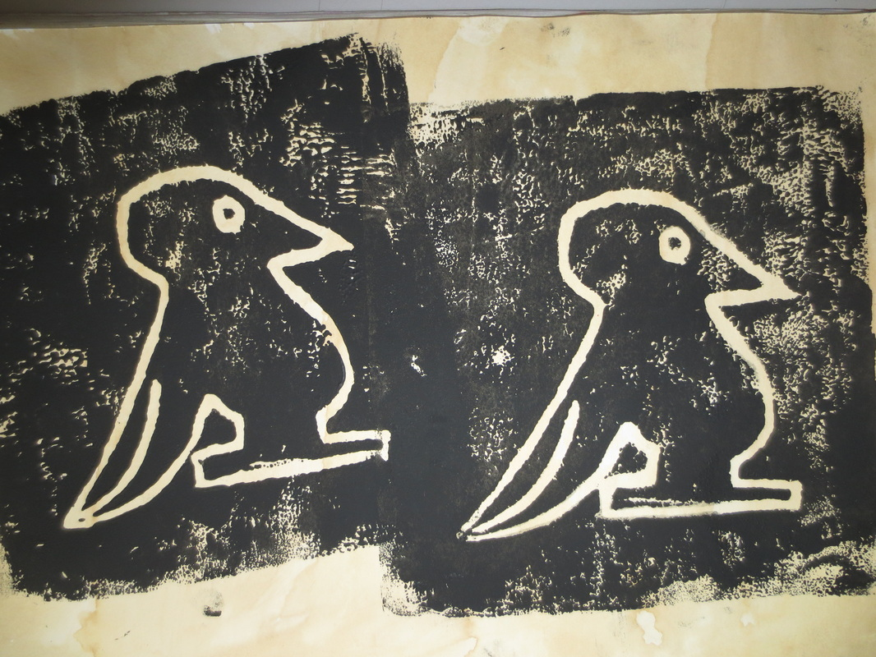 |  | ART FOCUS: Pottery  Key skills: coil pottery  Outcomes: Brightly coloured canopic jars  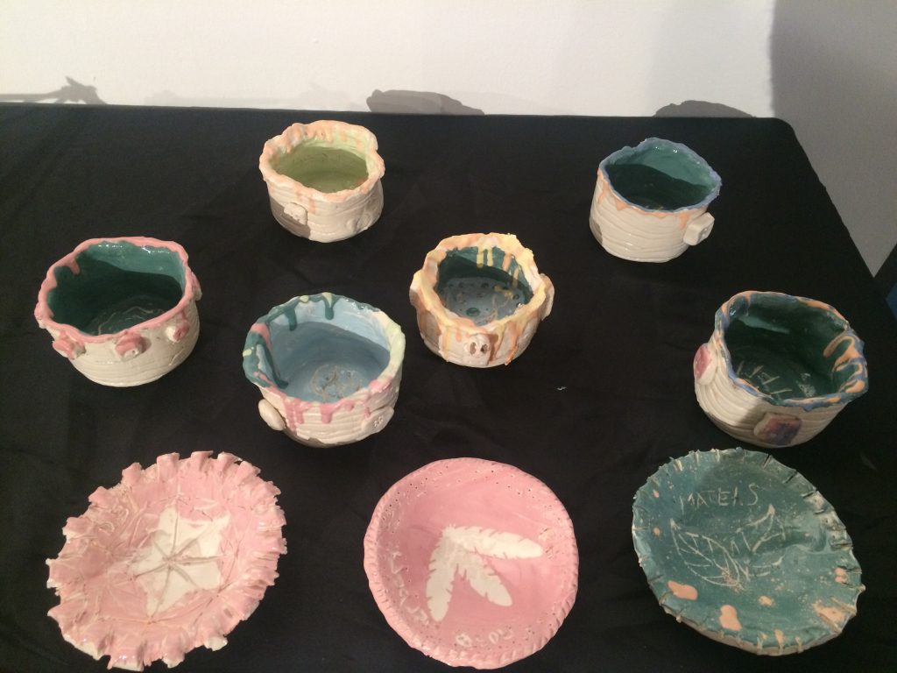
DT |  | Shell Structures  Project Outcome: Design, explore examples of, and make packaging for a sandwich. |  | Cookery healthy meals  Project Outcome: Design, explore examples of, and make a healthy meal |  | Textiles – Applique / cross stitch  Project Outcome: Design, explore and make an Egyptian Collar
RE |  | Focus: Christianity – Jesus’ teachings and messages  Concept: Message  Content:  explain the concept of messages  explain what Christians believe Jesus’ messages are  explain the value of Jesus’ messages to Christians and identify and describe some issues raised  express a personal response to messages in their own experience  explain examples of how messages are significant in their own and others’ lives and in different situations. | Focus Christianity - Angels  Concept: Angels  Content:  describe their own responses to angels.  describe examples of how their responses to angels can be applied to their and others’ lives.  describe the meaning of angels.  describe how angels are used in the stories of the birth of Jesus.  evaluate the importance of angels by describing their value to Christians and by identifying an issue raised. | Focus Hinduism – Good/Evil  Concept: Holi  Content  describe the concepts of good and evil  describe ways in which Hindus remember good and evil in the story and celebrations of Holi  describe the value of the ways in which good over evil is celebrated and identify an issue raised  describe their responses to the concepts of good and evil  describe incidents in their own and others’ lives where good comes out of evil. | Focus Christianity – Key events of holy week  Concept: Suffering  Content  describe the concept suffering.  describe the suffering experienced by Jesus in the Easter Story  evaluate the importance of the concept ‘suffering’ by describing in simple terms the value of Jesus’ suffering at Easter to Christians and talking about an issue raised  describe their own responses to suffering  identify examples of how their responses to suffering relate to their own and others’ lives | Focus Hinduism – Raksha Bandhan  Concept: Protection  Content  Children can express a personal response to the concept of protection.  Children can describe how the concept can be applied in their own and others’ lives.  Children can describe what protection means.  Children can describe how protection is expressed by Hindus in the festival of Raksha Bandhan.  Children describe the value, for Hindus, of celeb  rating protection. | Focus Christianity/Hinduism – Places of worship  Concept: Sacred places  Content  Children can describe what people mean by sacred  Children can describe a sacred place which is significant to believers  Children can describe the value of sacred places to and believers and to themselves  Children can express a personal response to the concept of sacred by reflecting on whether there is a sacred place in their own lives  Children can describe how sacred places can affect their own and others’ lives
Personal Development |  | Settling in  New rules and expectations, where can I get help? How can I help myself and others? Working with others and teamwork, respectful relationships | Focus on feelings  Talking about feelings and developing the language to talk about feelings, recognising their impact on others and their role in developing secure friendships | Making friends  Being a good friend, what makes others happy,sad and angry? How do we resolve conflict with others? How do our actions online affect others?  Online friendships | Keeping safe in school  Bullying, how to stop bullying, knowing and understanding safety rules for medicines alcohol and drugs, boundaries and respectful relationships, safe online relationships | In someone else’s shoes  Recognising the feelings of others, recognising different views and perspectives, recognising differing cultures and religions, an awareness of how social media can be used to bully/harass etc | Physical activity and nutrition  Balanced, health lifestyles to include mental wellbeing, good physical and mental health
PE |  | Coordination  Footwork  Static Balance  One Leg  Hockey | Dynamic Balance to Agility  Jumping and Landing  Static Balance  Seated  Netball | Dynamic Balance  On a Line  Coordination  Ball Skills  Tag Rugby | Coordination  Sending and Receiving  Counter Balance  With a Partner  Badminton | Agility  Reaction / Response  Static Balance  Floor Work  Rounders | Agility  Ball Chasing  Static Balance  Stance  Athletics
Music |  | I’ve Been to Harlem – Pitch shape, Ostinato, round, pentatonic, call-and-response, progtession snapshot 1.  Pentatonic Ostinato  Call and response – holding notes confidently  Melodic and rhythmic accompaniments  Identify where the notes go up and down in songs. | Nao chariya de/ Mingulay boat song – Bengali/Scottish folk songs comparing songs from different parts of the world, beat, tempo, 3/4, 4/4  Appreciation for music  Identify that songs are from different places in the world and have a different beat/ speeds  Folk songs are music that belongs to the people of a particular place  Sound Symmetry – structure, symmetry and pattern in melody, ternary form, melody, accompaniment.  Compose a simple song using symmetry to develop melody, structure and rhythmic accompaniment.  Sing by improvising simple melodies and rhythms  Identify how the pitch and melody has been developed using symmetry. | Latin Dance – Salsa, beat, clave rhythm, timbre, chords, rhythm pattern, progression snapshot 2  Compose a 4-beat rhythm pattern to play during instrumental sections.  Working in small groups, sing a call-and-response song with an invented drone accompaniment.  Sing the syncopated rhythms in Latin dance and recognise a verse/chorus structure.  Play a one-note part contributing to the chords accompanying the verses.  Listen to a range of Cuban pieces, understanding influences on the music and recognising some of its musical features. | March from the Nutcracker – Rondo structure, beat, higher/lower, staccato, call-and-response, romantic ballet music.  Develop active listening skills by responding to musical themes through movement.  Understand the structure of rondo form (A-B-A-C-A).  Develop a sense of beat and rhythmic pattern through movement.  Experience call-and-response patterns through moving with a partner.  From a railway carriage – structure, repetition, round pattern, texture, layers, unison, timbre beat, classical music.  Explore ways to create word-based pieces of music.  Explore ways to communicate atmosphere and effect.  Listen and compare how different composers have approached creating word-based compositions. | Just 3 notes – pitch (notes C-D-E) durations, crotchet, quaver, semiquaver, crotchet rest, rhythm patterns, structure, minimalism, score, dot notation  Invent simple patterns using rhythms and notes C-D-E.  Compose music, structuring short ideas into a bigger piece.  Notate, read, follow and create a ‘score’.  Recognise and copy rhythms and pitches C-D-E.  Samba – carnival, fanfare, call-and-response, beat, percussion, word rhythms, music and community  Perform call-and-response rhythms vocally, by ear, using word rhythms, then transfer rhythms to body percussion/instruments.  Perform vocal percussion as part of a group.  Move in time with the beat of the music. Talk about what they have learnt about Brazil and Carnival (e.g. samba batucada instruments, playing in call-and-response, samba schools, that in Brazil music helps communities thrive, that word rhythms are an important way to learn rhythm patterns that you can freely express yourself at Carnival). | Fly with the stars – Minor and major chords (A minor, C major) chord, dot notation, durations, crotchet, quaver, crotchet rest, progression snapshot 3  Play the chords of Fly with the stars on tuned percussion as part of a whole-class performance.  Sing solo or in a pair in call-and-response style.  Respond to and recognise crotchets and quavers, and make up rhythms using these durations to create accompaniment ideas for the song.
French |  | Numbers 0-6, greetings,  Colours, Animals  Responding to classroom phrases.  Christmas |  | Numbers 7-10  Celebrations – New Year  Seasons  Items we use in the classroom  Learning about Renoir, Eiffel tour |  | Numbers 11-31  Items of clothing  Days of the week, Adverbs of time  Clothing  Monet

