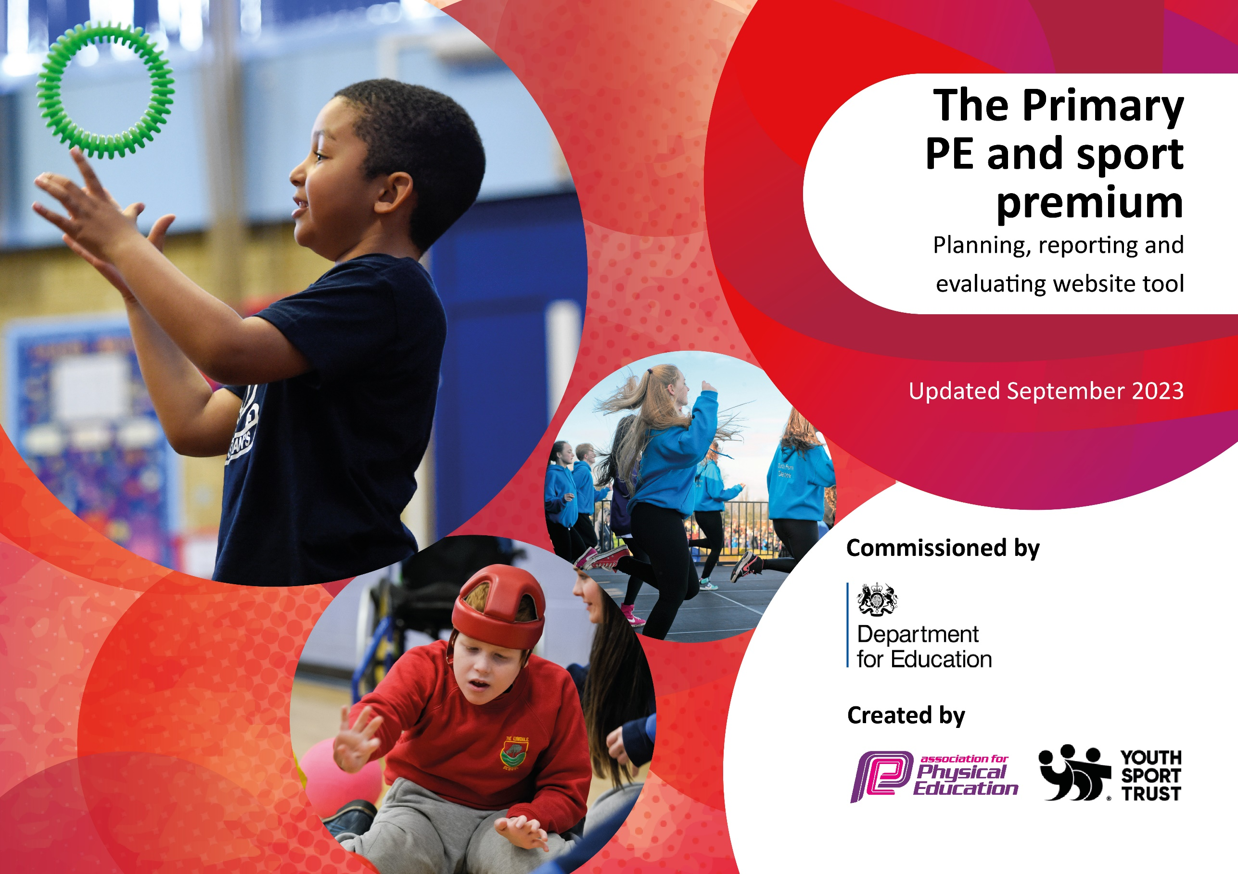

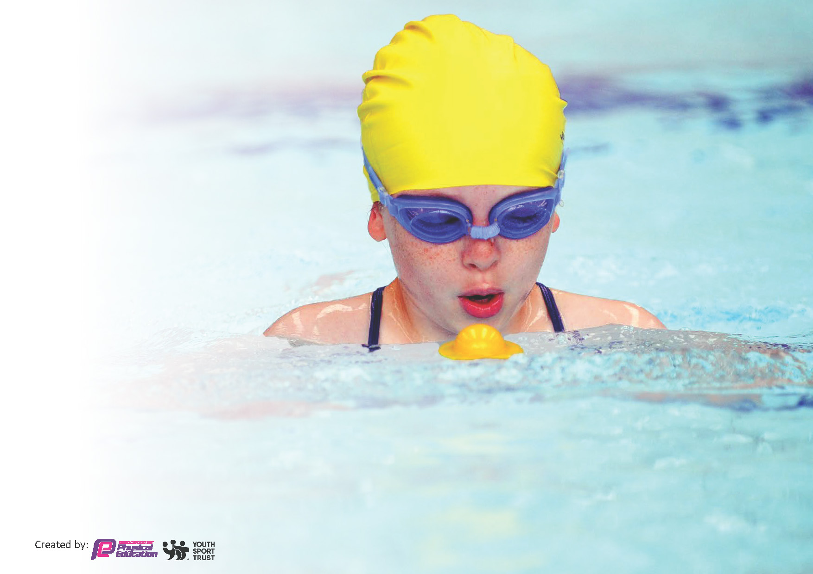
This template can be used for multiple purposes:
by:
- It enables schools to effectively plan their use of the Primary PE and sport premium
- It helps schools to meet the requirements (as set out in guidance) to publish information on their Primary PE and sport premium
- It will be an effective document to support Ofsted inspections enabling schools to evidence progress in Physical Education (PE) and evidence swimming attainment, which forms part of the PE National Curriculum. We would recommend schools consider
the Intent, Implementation and Impact of any spend, as examined within the Education Inspection Framework.

It is important that your grant is used effectively and based on school need.

Schools must use the funding to make additional and sustainable
improvements to the quality of the PE, School Sport and Physical Activity (PESSPA)
they offer. This means that you should use the Primary PE and sport premium to:

- Build capacity and capability within the school to ensure that improvements made now will benefit pupils joining the school in future years
- Develop or add to the PESSPA activities that your school already offers.

The Primary PE and sport premium should not be used to fund capital spend projects; the school’s core budget should fund these. Further detail on capital expenditure can be found in the updated Primary PE and sport premium guidance.

The Primary PE and sport premium guidance, outlines 5 key priorities that funding should be used towards. It is not

necessary that spending has to meet all the key priorities, you should select the priorities that you aim to use any funding towards.

Although completing this template is not a requirement for schools, schools are required to publish details of how they spend this funding. Schools must also outline what the impact this funding has had on pupils’ PE and sport participation and attainment and how any spending will be sustainable in the future. All funding must be spent by 31st July 2024.

The Department for Education has worked closely with the Association for Physical Education (afPE) and the Youth Sport Trust (YST) to develop this template and encourages schools to use it. This template is an effective way of meeting the reporting requirements of the Primary PE and sport premium.
Review of last year’s spend and key achievements (2022/2023)

We recommend you start by reflecting on the impact of current provision and reviewing your previous spend.

Activity/Action | Impact | Comments
Resourcing EYFS and KS1 outdoor areas  Forest School  Countryside trust  REAL PE  External providers  NFSSP | Developing gross and fine motor skills in EYFS and across KS1  Engaging pupils in physical activity at break and lunch  Developing positive behaviour and PSED  Classes across the school regularly take part in Forest School with a trained staff member. Access to a wide set of resources.  Developing understanding of a healthy lifestyle  Previous spend on REAL PE training means that all staff are able to follow the REAL PE curriculum and deliver inclusive PE sessions  Children have had coach led sessions enriched by experts in cricket, dance, sports hall which has led to and uptake in extra-curricular activities taken up out of school  Children have regular opportunities to take part in sports with their peers in the local area | Children are actively taking part in climbing and risk taking in their play and lunch times.  Children and able to use balance more effectively and confidently.  Children are learning to play cooperatively together and help and support each other in their play and achievements.  All year groups take part in forest school with a growing set of resources. We have bee keepers in upper school who tend to the bees and also help harvest honey.  Children enjoy growing and learning about different vegetables and different recipes they can make.  Continued subscription to REAL PE and training means that staff are continuing to follow the curriculum and we further developed our staff training this year with training in REAL dance and REAL gym  Children who may be less active or have less access to extra-curricular activities have been able to take part in various classes and work shops and this has inspired them and parents to take these up out of school  A wide range of sports and children have taken part in workshops and competitive sports out of school and we will continue with this.

Key priorities and Planning
This planning template will allow schools to accurately plan their spending.

Action – what are you planning to do | Who does this action impact? | Key indicator to meet | Impacts and how sustainability will be achieved? | Cost linked to the action
To further develop the outdoor environment and resourcing to promote positive play at break and lunch | Lunchtime supervisors / teaching staff, coaches and play leaders - as they need to lead the activity  pupils – as they will take part. | Key indicator1 and 2 -The engagement of all pupils in regular physical activity – the Chief Medical Officer guidelines recommend that all children and young people aged 5 to 18 engage in at least 60 minutes of physical activity per day, of which 30 minutes should be in school.  Key indicator 4: Broader experience of a range of sports and activities offered to all pupils. | More pupils meeting their daily physical activity goal, more pupils encouraged to take part in PE and Sport Activities.  Independently and safely accessing equipment  In EYFS supporting safe development of gross motor skills through outdoor play  Update training for staff | £3376 costs for replenishing equipment

Further develop the learning environment and resources to develop gross motor skills  To further develop the learning environment to promote healthy lifestyles and positive mental health and self- confidence.  .  Development of PE lead and in turn wider understanding of how PE school sports and activity look across the school and interschool line  External workshops and extra-curricular activities to engage pupils with a wide range of skills and interests regardless of parental income  Opportunities for celebrating success across the year in sports with sports awards evening and sports day.  REAL PE dance and gym training to ensure all staff can confidently teach pupils.  Opportunities for involvement in a wide range of sports and activities with NFSSP and local secondary schools.  Provide opportunities in class for competition.  Ensure that children are equipped for events  Additional provision over and above the national curriculum requirements | EYFS pupils and staff  Forest school staff and pupils across the school.  All children and staff training  PE lead  Sports coach  Play leaders  External providers  Pupils  Staff  KS2 All pupils in sports awards  All pupils in sports day  All staff  Specialised coaching  REAL PE staff  All staff  All children within workshops during training session  Sports coach  PE Lead  Other staff members to transport and over see  Children taking part in activities  Year 6 pupils  Staff to take and over see | Key indicator1 and 2 -The engagement of all pupils in regular physical activity – the Chief Medical Officer guidelines recommend that all children and young people aged 5 to 18 engage in at least 60 minutes of physical activity per day, of which 30 minutes should be in school.  Key indicator 2: Increased engagement of pupils in physical activity  Key indicator1 and 2 -The engagement of all pupils in regular physical activity – the Chief Medical Officer guidelines recommend that all children and young people aged 5 to 18 engage in at least 60 minutes of physical activity per day, of which 30 minutes should be in school.  Key indicator 2: Increased engagement of pupils in physical activity  Key indicator1 and 2 -The engagement of all pupils in regular physical activity – the Chief Medical Officer guidelines recommend that all children and young people aged 5 to 18 engage in at least 60 minutes of physical activity per day, of which 30 minutes should be in school.  Key indicator 4 – offering a wider range of sports  Key indicator 5 – increase participation in competitive sports  Key indicator 3 Raising profile of sport across the school.  Key indicator 4 – offering a wider range of sports  Key indicator 5 – increase participation in competitive sports  Key indicator 3 Raising profile of sport across the school.  Key indicator1 and 2 -The engagement of all pupils in regular physical activity – the Chief Medical Officer guidelines recommend that all children and young people aged 5 to 18 engage in at least 60 minutes of physical activity per day, of which 30 minutes should be in school.  Key indicator 4 – offering a wider range of sports  Key indicator 5 – increase participation in competitive sports  Key indicator 3 Raising profile of sport across the school.  Key indicator 4 – offering a wider range of sports  Key indicator 5 – increase participation in competitive sports  Key indicator 3 Raising profile of sport across the school.  Key indicator1 and 2 -The engagement of all pupils in regular physical activity – the Chief Medical Officer guidelines recommend that all children and young people aged 5 to 18 engage in at least 60 minutes of physical activity per day, of which 30 minutes should be in school.  Key indicator 4 – offering a wider range of sports | EYFS and KS1 children can demonstrate that they have met the expected level of development for gross and fine motor skills.  Forest school resourced and provision for outdoor learning  Children understand what is meant by a healthy life style.  Make healthy choices and seek support when worried or anxious  Children will be able to identify ways they can regulate their emotions or negative feelings.  Curriculum planning to support all staff  Create a clear vision for increasing engagement  IPAD to record sports in and out of school.  Teacher and coach led sessions enriched with experts and ambassadors.  Children exposed to new sports and experiences. Less active also given extra sessions to ensure KI 1 is achieved.  Children are able to talk about awards for sport and PE. Value is shown to these awards and events by children and parents.  PE taught by trained staff with resources to facilitate all lessons including online planning  Visible progress and participation in these sports and activities  Regular opportunities to compete.  Children competing in a range of sports  A good proportion of children have competed against children from other schools  Children have access to equipment and clothing for events  A higher percentage of year 6 can now swim. A lot of these children missed out in COVID | £1200 for resources and staff training  £1500 for Stormbreak training, resources.  £2312 to release staff and engage in CPD  £866.32 IPADS and to continue to resource play leaders  £360.00 for dance  £840.00 for Jump Start Johnny visit  £600.00 extra forest school sessions.  £760 – Residential trips  £300 for awards ceremony and specialised coaching  £1520  Includes REAL PE training delivered at staff meetings and during the school day by REAL PE staff.  Monitor lessons and coaching given as required.  £1800 NFSSP  £1000.00 equipment and uniform  £1200 for top-up swimming lessons and transport.

Key achievements 2023-2024
This template will be completed at the end of the academic year and will showcase the key achievements schools have made with their Primary PE and sport premium spending.

Activity/Action | Impact | Comments
Storm break  REAL dance and PE training  External providers coming in to school | All classes partake and enjoy Stormbreak. It often helps resolve lunchtime issues and gives children a well needed movement break during lessons.  Staff are now trained and confident in teaching these areas of the curriculum  All children benefited from extra physical activity from specialists  Children less active or less able to afford to have the opportunity for extra sport activities have been given the opportunity to do so. | Children already identify their favourite Stormbreak and children in EYFS are beginning to link to their feelings.  Classes are implementing sensory circuits to their Daily Mile and within their day to help prepare for learning and focus for activities.  Pupils have participated in dance and gym lessons  Staff have a knowledge of using equipment safety  Some children have now taken up these activities out of school.  Whole school was engaged with the workshops provided.

Swimming Data
Meeting National Curriculum requirements for swimming and water safety.
Priority should always be given to ensuring that pupils can perform safe self-rescue even if they do not fully meet the first two requirements of the National Curriculum programme of study

Question | Stats: | Further context  Relative to local challenges
What percentage of your current Year 6 cohort can swim competently, confidently and proficiently over a distance of at least 25 metres? | 60% | These children missed out on swimming at school due to COVID  Only 30% could swim 25 meters prior to the top up lessons.
What percentage of your current Year 6 cohort can use a range of strokes effectively [for example, front crawl, backstroke, and breaststroke]? | 60% | 30% of these children achieved this in year 6 with the top up lessons.

What percentage of your current Year 6 cohort are able to perform safe self-rescue in different water-based situations? | 75% | Most of the class can swim at some distance and would understand the dangers of the water and not put themselves at risk unnecessarily. However those unable to swim confidently at any distance would struggle to get themselves to the side or the shore.
If your schools swimming data is below national expectation, you can choose to use the Primary PE and sport premium to provide additional top-up sessions for those pupils that did not meet National Curriculum  requirements after the completion of core lessons. Have you done this? | Yes | Current year 6 had top up in their final year. These children also missed out on swimming due to COVID.
Have you provided CPD to improve the knowledge and confidence of staff to be able to teach swimming and water safety? | Yes | We do give lessons and have had CPD on water safety. We also send information home to parents and have assemblies on it.

Signed off by:

Head Teacher: | E.Moakes
Subject Leader or the individual responsible for the Primary PE and sport premium: | J.Marsh
Governor: | L.Taylor
Date: | 23.7.24

