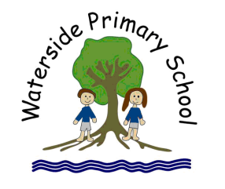

Waterside Primary School

Relational Support
Practice and Policy
2023

Vision:

At Waterside Primary School, our vision is to be an inclusive school in which all children can ‘Be the best we can be’ by enjoying an outstanding learning experience, making good progress and leaving us as responsible, happy citizens who continue to be eager to learn. As a school we have high expectations of behaviour displayed by children and by all stakeholders. Positive behaviour is part of a learning process and is reflected through a sense of identity, worth and respect for self and others.

Ethos:

Here at Waterside Primary School, we believe that genuine connections between our staff and our pupils are the fundamental foundation of positive behaviours and will allow staff to set the highest of expectations of pupils and themselves. We recognise that some behaviours can stem from an unmet need and that the child does not yet have the skills to express appropriately. In this instance, we will do our utmost to identify this need and develop an appropriate individual approach.

Aims:

Our aims are for all children, parents and staff to be aware of their responsibilities with regards to conduct, relationships and behaviour.
Together we will:
- Build and maintain positive relationships
- Promote self-esteem
- Promote self-regulatory behaviours with courageous compassion
- Ensure a consistent inclusive approach to the individual recognising their innate worth.
- Develop a profound understanding of need
- Promote the sense of inclusivity through the practice of equity

Whole School Values:

It is our expectation that every child is:
Ready | Respectful | Safe
Ready to learn  Ready to achieve my potential  Ready to make mistakes and learn from them  Ready to learn independently  Ready to learn with others  Ready for the next phase of education | Respectful of the rights for other children to learn  Respectful of the right for teachers to teach  Respectful of differences  Respectful of the school environment  Respectful of the school community | Safe to be me  Safe in my environment  Safe in my community  Safe with equipment  Safe online  Respectful of the safety of others

Theory and Research:

We have used the advice and publications provided by the Department of Education (DfE) such as Mental Health and Behaviour in Schools and from the Education Endowment Fund (EEF); Improving Behaviour in Schools.
We draw on research from the fields of Neuroscience, Attachment theory, Trauma research, and research into Adverse Childhood Experiences. Using the research and works of Louise Bomber, Dan Siegel, Dan Hughes and others of note in this field of expertise.

Three part Graduated Response:

Developing Relationships
We place relationships at the heart of what we do at Waterside Primary School and all staff will actively seek to build strong, positive relationships with the children and their families. We recognise that the PACE approach (Dan Hughes), Playful, Accepting, Curious and Empathetic, supports the children to learn to feel safe, to belong, to understand themselves and others, and the world.

Responding and Regulating
We understand that due to the prior experiences, additional needs and environmental triggers, some of our children will communicate their needs through discharge behaviours that can challenge those around them. In order to support them we need to be able to ensure their safety, to attune and validate. When the child is ready, we can soothe and regulate. This involves being able to empathise with their feelings and understand their thinking. We use our knowledge of brain development and the response of the body to interpret what we need to do to meet their needs.

Repairing and Restoring
Step three relies on the child being calm and ready to reflect. This step should not be initiated too soon. We help our children to recognise what has happened, why it happened, who was impacted and how they can learn different behaviours to meet their needs and move forward positively. We remember that punitive responses and shame can lead to feelings of worthlessness and helplessness and do not help our children to repair and restore, or learn new more helpful behaviours top meet their needs.

Developing Relationships and reinforcing high expectations of conduct:
At Waterside we ensure the consistency of our approach through explicit teaching and modelling of our high expectations.
Praise
We give descriptive praise to acknowledge our expectations being met. We will use encouraging language to show our awareness of the positive choices being made. We will also give visual praise through smiling, thumbs up etc.
Rewards
We give rewards as an acknowledgement of the positive choices and achievements made. These rewards will be:
Stickers – generally awarded for demonstrating effort in learning
Leaves – generally awarded for demonstrating exceptional effort in learning and conduct
House points – generally awarded for demonstrating self-determining positive and respectful conduct
Class ‘gems’ – generally awarded for whole class achievements, teamwork, and collaboration.

Leaves are collected and displayed on a class tree. It is important that the adults use the leaves to explicitly identify the learning behaviours that a child has demonstrated. When five leaves have been achieved the child is awarded a Head Teacher’s Award certificate which is taken home following a Celebration assembly. The leaves are replaced on the class tree with an apple. When 3 apples (Head Teacher’s Awards) are achieved the child will receive a Governor’s Award.

House Points are collected and counted each week. The children across the school are members in one of four houses; Earth, Fire, Air, Water. The house captains collect, count, and share the results during the week’s celebration assembly. At the end of every term the winning house will come into school on a chosen day in non-school uniform.

Class Gems or other collectable objects are added to a class jar for whole class achievements, teamwork and collaboration. When the jar is full the class choose a reward that will take place one afternoon.

Communication with parents
Communicating with parents is as important for the child as the reward itself. There are opportunities at the start or end of the school day to share positive messages. We can also communicate through email, or phone call.

Responding and Regulating:

At Waterside we understand the importance of the adult remaining calm when faced with a child’s emotional distress. We use a common language of recognising that the child is experiencing an emotion causing distress. We ensure that the situation is safe as soon as possible. To attune with the child, we use our own regulatory systems.

Repairing and Restoring:

We believe there are natural consequences of an action that inform a change in conduct. However, it is important for all to understand that missed learning time, activities and or work do need to be caught up with.

All children will use the ‘Ready, Respectful and Safe’ language and approach when in school every day. Occasionally a child will arrive at school in an agitated state and not able to be ready for learning. All adults will be mindful of their relational skills (safety cues, curiosity, empathy, containment, soothing…)

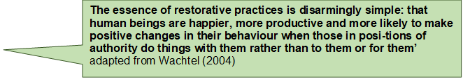

The 5 Restorative Questions
- What happened?
- What were you thinking or feeling at the time of the incident?
- What do you need?
- Who was affected by what happened? Who was harmed?
- What needs to be done to make things as right as possible for everyone involved?

Appendix:

All members of the school community will be expected to build respectful and trusting relationships with each other.

All children will have many opportunities to learn and have modelled to them the expectations of learning and social interactions.

This policy links with other policies and procedure documents, including gender/deversity, classroom environment and the guide to great teaching.

Things to remember:

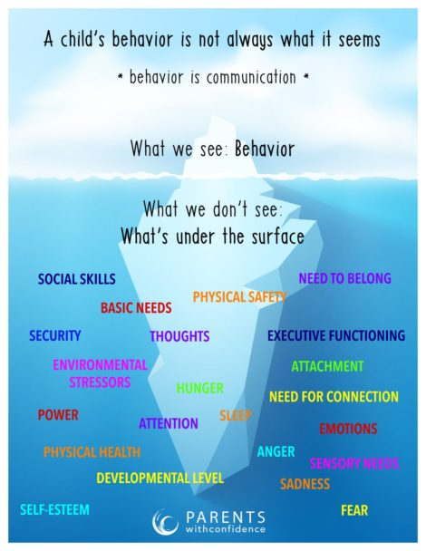
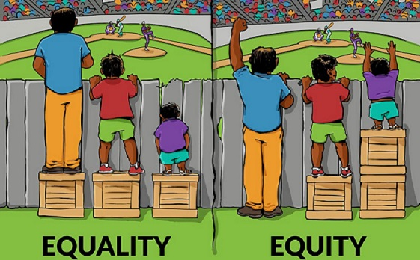
Why we tailor our responses to the needs of the children.

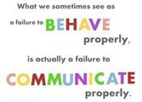

Version Number | Date of Issue
Original | September 2023
Ratified by Governing Body
Signed
Position
Review Period | Annually

