

Waterside Primary School
Special Educational Needs and Disability (SEND) Policy

We want our children to ‘Be the best they can be’. We provide a caring and supportive environment, with high expectations and a rich, broad and balanced curriculum. We want our children to leave Waterside having achieved their full potential.

We aim to be an inclusive school, and seek to remove barriers to learning and participation that can delay or exclude individual children. We are committed to meeting the needs of all children, ensuring that they make progress. We believe that all children should be given the opportunity to raise their aspirations and achieve their full potential.

Our SEND policy has been reviewed in line with:
  - SEND Code of Practice: 0 to 25 years (January 2015) https://assets.publishing.service.gov.uk/government/uploads/system/uploads/attachment_data/file/398815/SEND_Code_of_Practice_January_2015.pdf
  - The National Curriculum Inclusion Statement https://modgov.hillingdon.gov.uk/documents/s654/Appendix%20A%20Inclusion.pdf
  - Hampshire Local Authority (LA) Special Educational Needs Policy and Inclusion Statement and Local Offer https://fish.hants.gov.uk/kb5/hampshire/directory/localoffer.page?familychannel=6
  - Part 3 of the Children and Families Act 2014, which sets out schools’ responsibilities for pupils with SEND https://www.legislation.gov.uk/ukpga/2014/6/part/3/enacted
  - The Special Educational Needs and Disability Regulations 2014, which set out schools’ responsibilities for Education, Health and Care Plans (EHCP), SEND co-ordinators (SENDCos) and the SEND information report https://www.legislation.gov.uk/uksi/2014/1530/contents/made
  - Equality Act 2010 www.legislation.gov.uk/ukpga/2010/15/contents

.

We acknowledge the definition for Special Educational Needs as ‘where their learning difficulty or disability calls for special educational provision, namely provision different from and additional to…’(Chapter 6.15)SEND CoP 2015)

Objectives
- To enable all children to have access to High Quality Inclusive Teaching with a broad, balanced and relevant social and educational curriculum.
  - Having the ethos ‘All teachers are teachers for all children including children with SEND’.
- To identify any child with Special Educational Needs or disability as soon as possible.
  - To seek further professional support when the child’s needs cannot be met solely by school provision
- For all children to have their progress continuously monitored by the class teacher; ensuring effective, robust and rigorous assessment is in place
  - ensuring the child is able to reach their full potential
- To cater, wherever possible, for learning needs to be met within the curriculum
  - through adaptive teaching, resources, responsive provision, programmes and/or intervention
- To enhance the involvement of the child, the parent/carer and school staff in target setting
  - Enabling both child and parent/carer to celebrate success of meeting individual targets

Roles and Responsibilities
The Head Teacher will have overall responsibility for the day-to-day management of the provision for all pupils. They will:
- Support the SENCo to follow the policy
- Support the SENCo to source and attend any additional relevant training
- Support the SENCo to ensure consistency of procedure and provision across the school.

The Governing Body will review and evaluate the effectiveness of the Policy
and provision annually. They will:
- Appoint a SENCo – who will receive the relevant training
- Name a governor for SEN – who will act on behalf of the governing body
- Ensure that SEN provision is an integral part of the school’s development plan
- Challenge the effective use of funding, personnel, equipment and other resources

The SENCo will be responsible for the day-to-day operation of the school’s SEND policy. They will:
- Work closely with teaching staff – offering support, advice, research and training
- Updating and maintaining a register of children with SEND
- Overseeing the records of all children with SEND
- Working in partnership with teachers and parents to support the development of children with SEND
- Play an active part in the Team monitoring progress of all children across the school
- Liaise with external agencies, educational services to support the child. (including, but not limited to Educational Psychologist, LA Support, Primary Behaviour Services, CAMHs)
- Gather and collate information, assessment and reports to apply for additional support (Education, Health Care Plan)
- Oversee the implementation of an EHCP, review and work with LA to update plans.
- Contribute to the in-service training of staff
The SENCo will have the opportunity to work with the Cluster SENCos supported by Educational Psychologists to discuss advice and best practice.

The Class Teachers will be responsible for the planning and delivery of a broad, balanced curriculum. They will:
- Ensure all children have access to their high-quality inclusive teaching.
- Plan and provide adapted resources for a personalised learning plan for a child with SEND
- Assess, plan, do and review any child who is not achieving as expected.
- Take part in reviews for children with SEND
- Take responsibility for writing up and seeing to the implementation of ILPs (individual Learning plans) for children with SEND
- Seek advice and support in a timely manner from the SENCo and/or any other educational support professional.

Identification, assessment and provision for children with SEND
We strongly believe that a working practice of ‘equity’ – providing a child with what is needed to achieve – is more impactful than ‘equality’ –providing the same for everyone.

When the class teacher believes a child has a significant barrier to learning that will require “additional to and different from” provision, they will look for support, assessment, resources and strategies from the SENCo. The class teacher will plan an appropriate provision that they will monitor with the SENCo. This provision is shared with the parents through shared dialogue including parents’ evenings and the school Individual Learning Plans (ILPs).

We encourage all children to work together and find that children with SEND benefit from working with children who do not have SEND.

We follow a graduated response when planning our support for children with SEN. Parents are informed if their child is either added to or removed from the SEN register.

The school uses Learning Support Assistants/ Teaching Assistants throughout the school. They work closely with the class teachers to provide support for all children within their allocated class. All LSAs/TAs are supported by the SENCo; are part of the ‘in-house’ training provided as well as receiving specific SEND programme training.

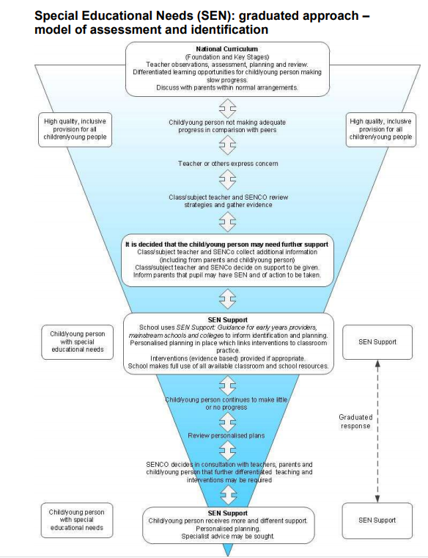

The school has good links with outside agencies from whom they can draw on advice, training and out-reach support. These professionals include but are not limited to Primary Behaviour Service (PBS Clifford Centre); Out-reach support from Forest Park School and Oak Lodge School; Hampshire Educational Psychologists Service; NHS Children’s Therapy Service, which includes Speech, Language and Communication.

This policy is accessible to all staff, governors and parents/carers. It will be part of the governing body’s policy review cycle.

The SENCo can be contacted by telephone, 02380842143 or by email l.baird@waterside.hants.sch.uk

In conclusion, Waterside Primary School works alongside the SEND Code of Practice (January 2015) to provide all children and young people with special educational needs and disabilities to secure good outcomes in the education.

Information | Date
Version 2 | September 2023
Ratified by Governing Body
Signed
Position
Review Period | annually

