Forest School:

The children will continue to enjoy forest school in Spring 2.

They will experience the change from winter to spring and can expect some cold weather.
They will need to come to school ready for their time outside and will need warm clothing, a waterproof coat and wellies to change into.
Art, DT and Music: 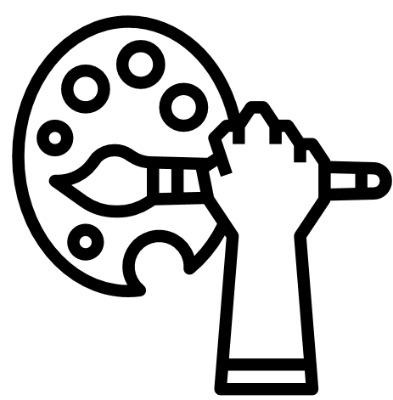 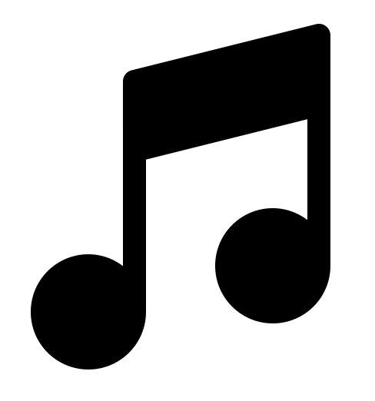

DT: In DT the children will be learning how to make sliders and levers. They will then make moving pictures that they will share with you at home.

We will continue to incorporate music into the curriculum, using songs to help us learn and providing opportunities to experiment with musical instruments.

Geography: 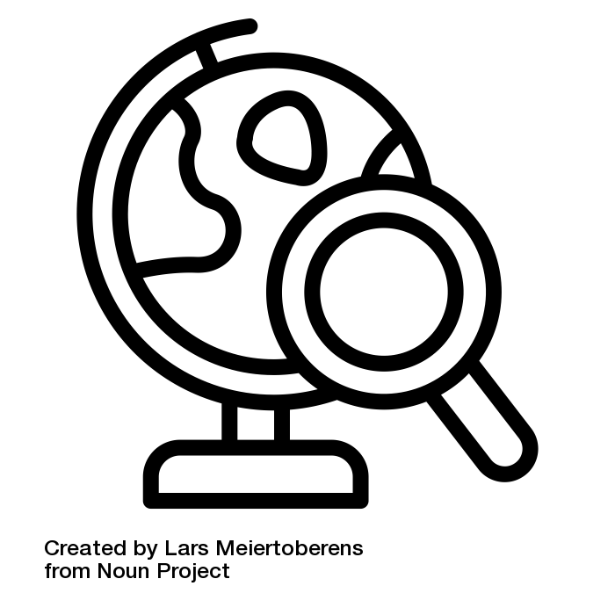

In spring the children will be looking at the countries of the United Kingdom. They will look at different landmarks across the UK. They will use map skills to find England, Ireland, Scotland and Wales.

We will continue to look closely at the weather and how it changes with the season. Asking the question, is it just as cold everywhere else?

PSHE: 

Caring for myself: In Spring 1 we will look at ways in which we can stay fit and healthy, to understand that some household products can be harmful to us and looking at what is right and wrong.

Caring for others: In Spring 2 we will discuss the importance of contributing to the class and school community, working and playing co-operatively and the importance of listening to others.

RE: 
In Spring 1 we will look at Passover and what remembering means. We will describe ways in which Jews remember the Passover story and discuss remembering our own experiences.

In Spring 2 we will describe the concept of welcoming and how Christians re-create the story of Palm Sunday. We will think of times when we have felt welcomed.
Ways to help at home:

Please encourage your child to become a regular reader by logging on to Bug Club. Read to them regularly. Help them with their ‘Tricky Words’, practising counting in 2s, 5s and 10s and telling the time to o’clock and half past the hour.

Also please continue to help them read and write their weekly spellings.

You will have received Key Instant Recall Facts for the Spring Term with this letter – it would be helpful if you could support your child and school by practicing these recall facts at home.

Y1 Spring 2026
The United Kingdom

PE: 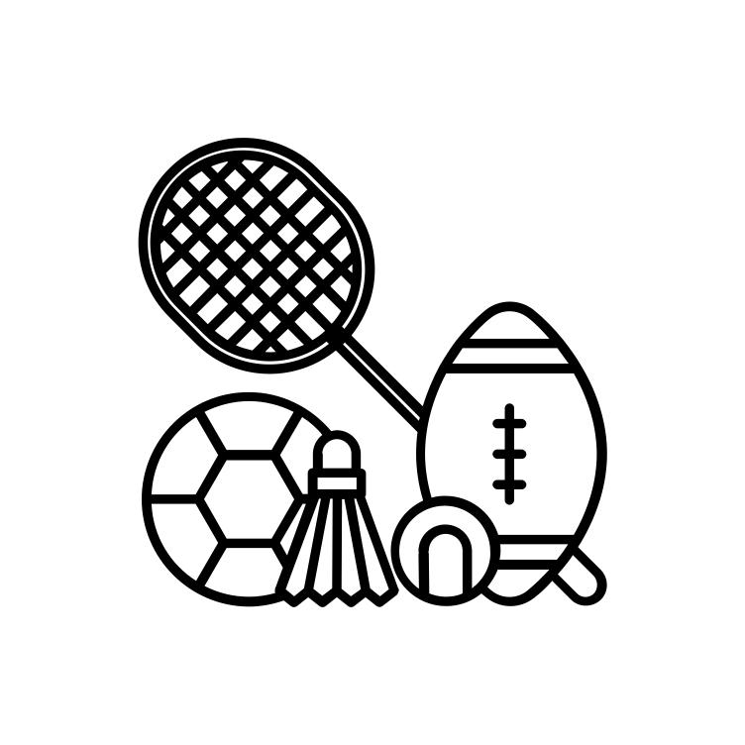
We will continue to work through our “Real PE” skills of agility, balance and coordination alongside Miss Jacob’s outdoor multi skills and games lessons.

Please could children continue to bring their kits to school ready for PE on Mondays and Thursdays. Tracksuit trousers and tops will ensure the children are warm enough when the lesson is outside. Any children with pierced ears need to have earrings removed or taped on PE days.

Y1 Spring 2026

Any queries please contact us via emailing or phoning the office or stopping at the gate.

Literacy: 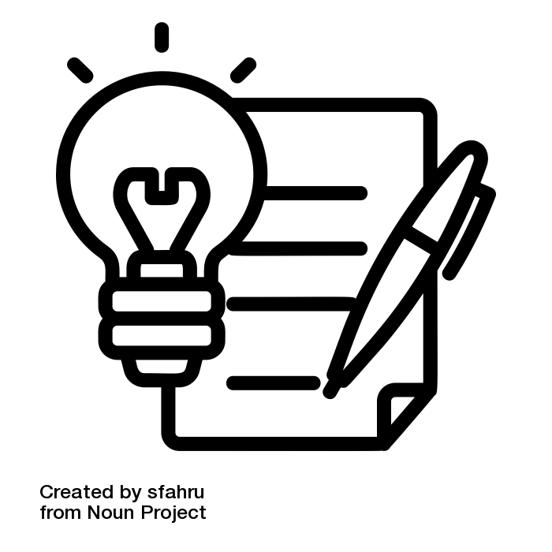
Year 1 literacy is linked to high quality texts or events to inspire and excite us as readers and writers.

Spring 1 will be focused on recount writing. We will start by talking about our Christmas holidays. We will be making bread then writing about how we made it. Finally, we will be reading various books about a King!

Spring 2 will involve the children having a visit from someone or something! We will study the book Meerkat Mail and we will find out about meerkats. The children will produce postcards as if they had visited somewhere special and an information page to contribute to a whole class book for the library.

Shared Reading: During shared reading the children will read a variety of books as a class. We will predict what may happen in the story and give justifications to our opinions.

The children will continue to build confidence in speaking aloud and will have opportunities to perform to a small audience.

Science: 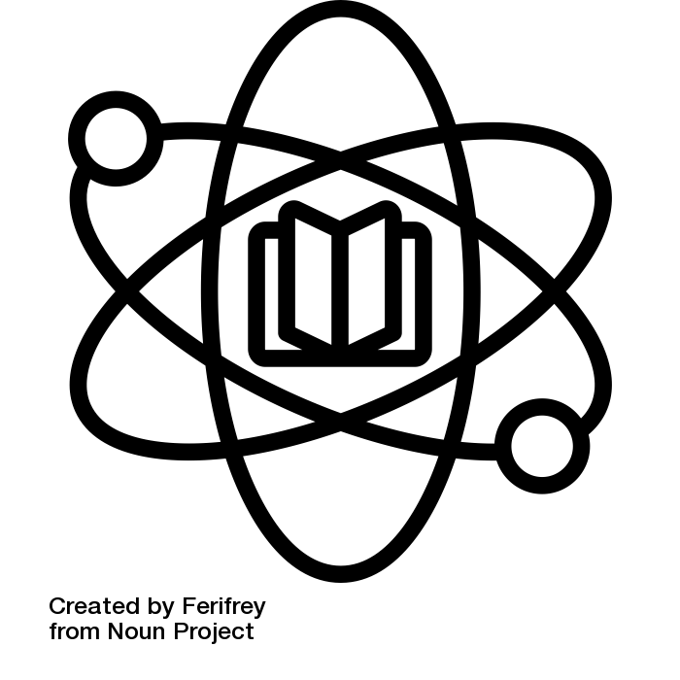
In science we will be looking at everyday materials. We will ask questions about which material is best suited for different jobs. For example, building a house, keeping us dry or keeping us warm.

Children will have opportunities to use their enquiry skills and make investigations as a scientist.

Phonics: 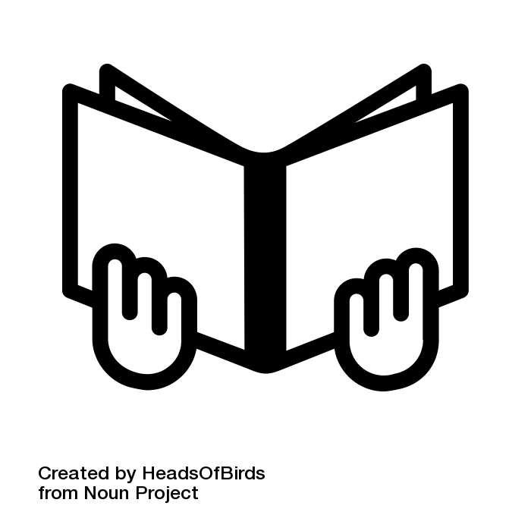
In Spring 1 and 2 the children will continue with their learning of phase 5 in phonics, learning to blend their sounds for writing and also to learn to spell their ‘Tricky Words’.

They will also be looking at alternative sounds to the ones they are now confident in. If you would like any ideas to support their learning at home please contact us via email.

Please continue to support your child by using Bug Club daily at home.

Numeracy: 

During this term, the children will be working on:
- Addition and subtraction
- Geometry, recognizing and naming 2D shapes. To be able to say what is the same and what is different. Explore different orientations of the same shape.
- Problem solving
- Multiplication and Division
- Measure – capacity, time, months and days
- Number bonds to 20

