
KS2 Children will no longer be offered fruit. However, they are more than welcome to bring in a piece of fruit from home to eat during playtime.
They are welcome to bring in money for the tuck shop. This would be no more than £1 a day please.
Tuck
Please arrive into school from the bottom gates which can be found at Langdown Road.
Children can walk from the gates into the Year 3/4 doors where an adult will meet them. Collect at the end of the day from the doors.
Arriving at school
All children have a login for Bug club. I would like to see everyone accessing Bug club. We will be promoting daily reading books in addition to keep reading fluency going.
Bugclub
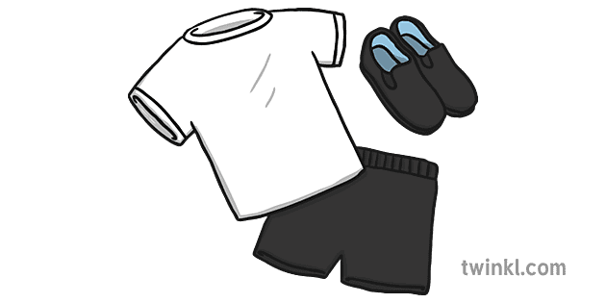


We are also very lucky that on a Monday afternoon, the children will be learning instrumental lessons with Hampshire Music. This half term the children will be learning the Toot instrument! Please ask your child all about their first lesson!
P.E
PE will be on a Tuesday morning and a Thursday Afternoon Children must bring PE kit on Tuesday morning and can leave it in school if they so wish.
Tuesday morning is Hockey, outside -unless the weather is unkind to us . Thursday afternoon will be in the hall using the apparatus and learning core skills.
We already have some rock stars.
Keep up the daily practice as we learn more of our times tables.
TTRS
Homework grids will be sent half termly linked to our class learning!
Please continue with these.
Weekly spellings, handwriting practice and times tables activities will also be sent out.

Homework
We welcome you all into Year 3 and are really looking forward to getting to know you all over the coming weeks. Please do come and speak with us, should you have any worries. Thank you
Mrs Goodey
Welcome to Year 3 - 2025!

